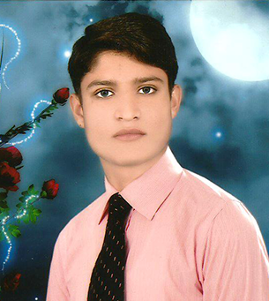
––ver

ATIF BASHIR
STREET # 13 MULLAH KOT HABIBULLAH MAIN BAZAR # 1 GUJRANWALA

Cell: +92 322 5560318

E-mail: atifchaudhry_98@yahoo.com atifchaudhry532@gmail.com

Carrer Objective:

Willing for challenging and rewarding career position in a leading and reputable organization renowned for its professional work environment. The position that I am looking forward to have self-development opportunities and good prospects for advancement and excellence.

Academic Qualification:

- Matriculation (Science) Board of Intermediate & Secondary Education GRW . 2015
- F.A (In progress) Allama Iqbal Open University Gujranwala. 2015

Personal Profile:

Full Name: Atif Bashir
Father’s Name: Muhammad Bashir
Date of Birth: 11-02-1998
CNIC # 34101-1417214-3
Marital Status: Married
Nationalité: Pakistan
Religion: Islam
Domicile Gujranwala

Professional Skills:

- Punctuality.
- Efficient, honest and hard working
- Self motivated
- Can communicate frequently in English, Urdu & Punjabi
- Self-starter and seeks new challenges and responsibilities
- Ability to organize and prioritize the tasks and work under pressure
- Take paride in hard Works.
- Command over written/spoken Urdu, English and Punjabi.
- Like to work in challenging and professional environment.
Experience:

- 1 Year Working Experience as a Book Composer in INTERNATIONAL ISLAMIC BOOK FOUNDATION People Colony Gujranwala.

- 4 months working Experience as a Graphic Designer in CAD CAM MACRO, FLIP ART STUDIO Bahria town Rawalpindi.
- 2 Months working Experience as a Graphic Designer in TENBYTE Bahria town Rawalpindi.
- 1Years Working Experience as a Graphic Designer in UDNA (P.V.T) Bahria town Rawalpindi.
- 4 Months working Experience as a Graphic Designer in The Raydiex Bahria town Lahore.
- Currently Working as a Graphic Designer in Absologix Bahria Town Rawalpindi.

- .. (((All the Branches are the Jolta Technology (P.V.T) Baheria Town Rawalpindi)))..
Computer & Other Knowledge:

- Good commands on Microsoft Office ( Word, Excell & Power point)
- Good commands on Adobe Photoshop
- Excellent commands on In page
- Installation of windows & software
- General repairing & maintenance
- Up gradation
- System configuration
- Good typing speed
- Web browsing

Hobbies:

- Group activities
- Internet browsing
- Book reading

Reference:

- Will furnish upon request.

For more Information & detail please visit: www.atifbashir.weebly.com

Skype ID : atifchaudhry98

